Setup Proxifier

1. Install Proxifier-Install from Software Center.

Click on Proxy server to configure – (Click on Red Mark ) 🡪 Click on Add 🡪 Configure Proxy Server as mentioned in screenshot (**3**) 🡪 Click on Advanced to add custom label 🡪 Click on OK.

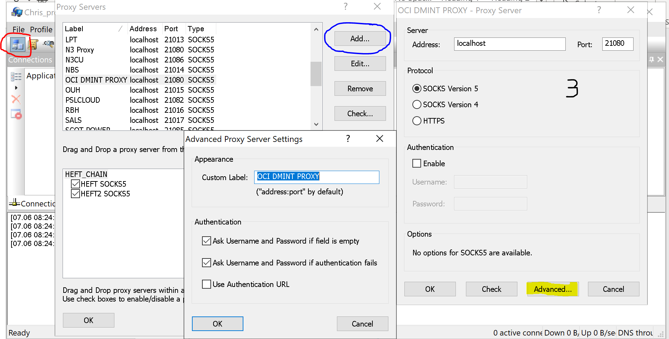

1. Next configure rules 🡪 Click on red highlighted area in screenshot🡪Add 🡪 Browser putty,winscp and sqldeveloper in application section🡪 Add target hosts : 10.0.0.0-10.0.6.255 🡪 Action = proxy server configured in above step 🡪 Click Ok

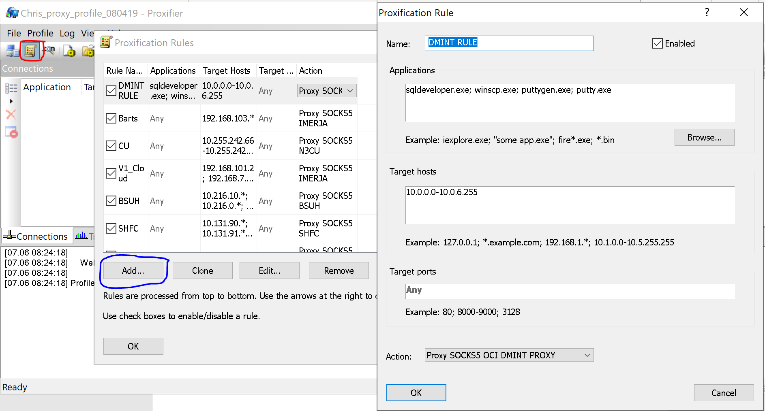

1. Open putty and create a connection with hostname and port as below, add a session name, e.g. V1 ERP OCI JUMP, and save the session.

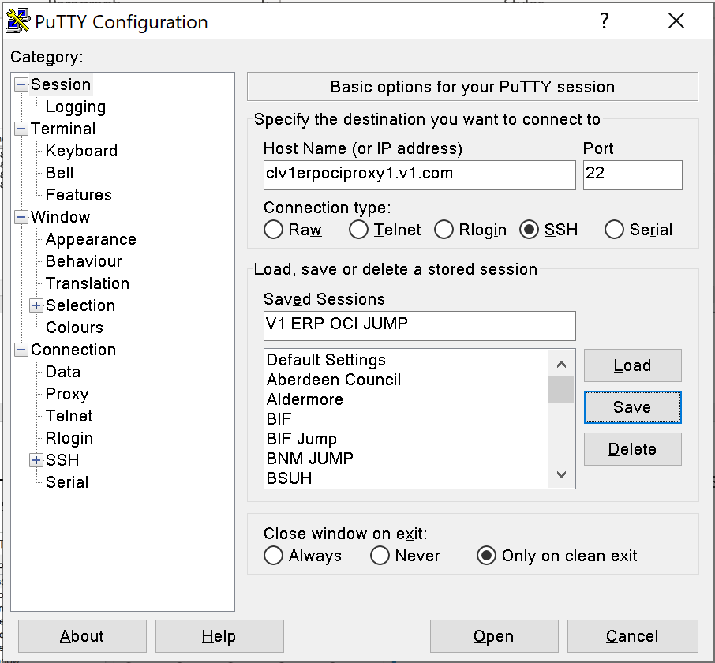

1. Change tunnels setting as follows: Add 21080 to Source Port and 127.0.0.1:1080 to Destination and click Add.

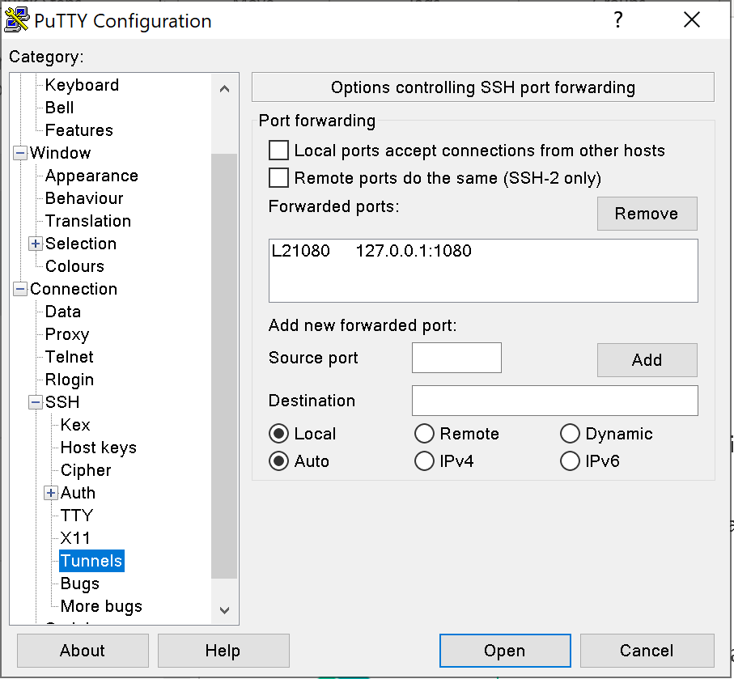

Important, click back on session and click save

Setup MXDM DB Connection

1. Open putty again and create a connection with hostname and port as below, add a session name, e.g. OCI MXDM, and save the session. **(Change IP from 10.0.1.9 to 10.0.1.192)**

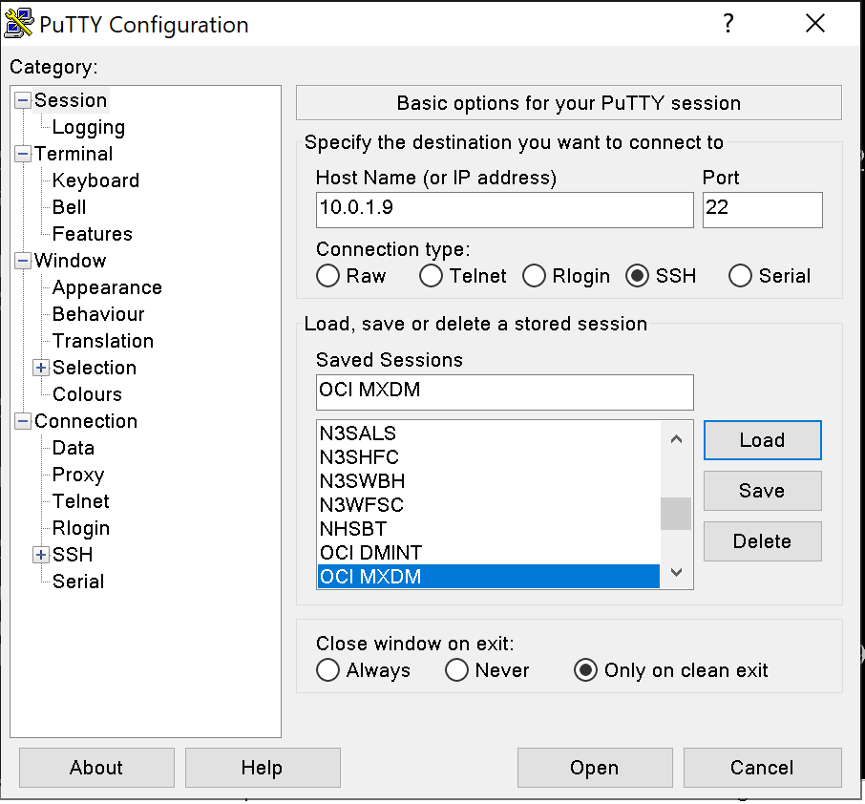

1. For the same session expand SSH and select Auth 🡪 Click on Browse and navigate to the ssh_key_v1erp_mxdmdb.ppk file saved previously. Also, enable “Allow agent forwarding” option.



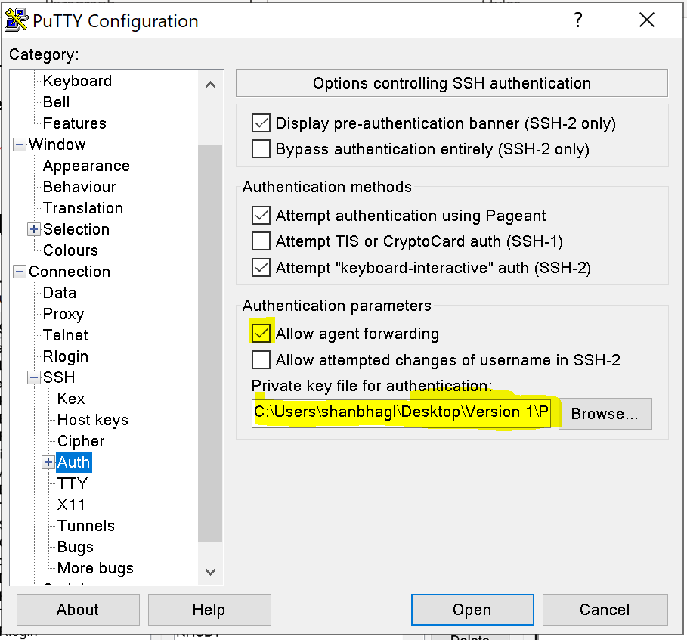

Important, click back on session and click save.

1. To connect to MXDM server, launch Jump host (from step 4) and then launch MXDM (from step 6). This will launch a putty session to the server.

Login with username opc, no password is required because we are using the ppk file.

Once logged in as opc you need to switch to the oracle user, to do this enter the command:

sudo su – oracle

**SQL Developer Connection Setting for MXDM:**

Username – **XXMX_CORE, XXMX_STG, XXMX_XFM**

Password – Password in PMP

Hostname – 10.0.1.192

Port - 1521

Service Name - MXDM_PDB1.apexfra1red.apexvcn.oraclevcn.com

